UNITED STATES SECURITIES AND EXCHANGE COMMISSION
Washington, D.C. 20549
FORM 8-K
CURRENT REPORT
Pursuant to Section 13 or 15(d) of the Securities Exchange Act of 1934
Date of Report (Date of earliest event reported): August 5, 2026
LIFECORE BIOMEDICAL, INC.
(Exact name of registrant as specified in its charter)
Delaware |  |  |  |  |  | 000-27446 |  |  |  |  |  | 94-3025618
(State or other jurisdiction of incorporation) |  |  |  |  |  | (Commission file number) |  |  |  |  |  | (IRS Employer Identification No.)
3515 Lyman Boulevard
Chaska, |  |  | Minnesota |  |  | 55318
(Address of principal executive offices) |  |  |  |  |  | (Zip Code)
(952) 368-4300
(Registrant’s telephone number, including area code)
Not Applicable
(Former name or former address, if changed since last report)
Check the appropriate box below if the Form 8-K filing is intended to simultaneously satisfy the filing obligation of the registrant under any of the following provisions:
☐ Written communication pursuant to Rule 425 under the Securities Act (17 CFR 230.425)
☐ Soliciting material pursuant to Rule 14a-12 under the Exchange Act (17 CFR 240.14a-12)
☐ Pre-commencement communications pursuant to Rule 14d-2(b) under the Exchange Act (17 CFR 240.14d-2(b))
☐ Pre-commencement communications pursuant to Rule 13e-4(c) under the Exchange Act (17 CFR 240.13e-4(c))
Securities registered pursuant to Section 12(b) of the Act:
Title of each class |  |  |  |  |  | Trading Symbol |  |  |  |  |  | Name of each exchange on which registered
Common stock, par value $0.001 per share |  |  |  |  |  | LFCR |  |  |  |  |  | The NASDAQ Global Select Market
Indicate by check mark whether the registrant is an emerging growth company as defined in Rule 405 of the Securities Act of 1933 (§230.405 of this chapter) or Rule 12b-2 of the Securities Exchange Act of 1934 (§240.12b-2 of this chapter).
Emerging growth company ☐
If an emerging growth company, indicate by check mark if the registrant has elected not to use the extended transition period for complying with any new or revised financial accounting standards provided pursuant to Section 13(a) of the Exchange Act. ☐

Item 2.02 Results of Operations and Financial Condition.
On August 5, 2026, Lifecore Biomedical, Inc. (the “Company”) issued a press release announcing its consolidated financial results for the second quarter and six months ended June 30, 2026. The press release is furnished herewith as Exhibit 99.1.
The information in this Item 2.02 of this Current Report, including Exhibit 99.1, is being furnished and shall not be deemed “filed” for purposes of Section 18 of the Securities Exchange Act of 1934, as amended (the “Exchange Act”) or otherwise subject to the liabilities of that Section. The information in this Item 2.02 of this Current Report, including Exhibit 99.1, shall not be incorporated by reference in any filing under the Securities Act of 1933, as amended or the Exchange Act, except as shall be expressly set forth by specific reference in such a filing.
Item 7.01 Regulation FD.
On August 5, 2026, the Company made available on its website certain investor presentation materials (the “Investor Presentation”). A copy of the Investor Presentation is furnished as Exhibit 99.2 to this Current Report on Form 8-K and is incorporated by reference in this Item 7.01.
The information furnished in this Item 7.01 of this Current Report on Form 8-K (including Exhibit 99.2 attached hereto) shall not be deemed “filed” for purposes of Section 18 of the Exchange Act and shall not be incorporated by reference into any filing of the Company under the Securities Act of 1933, as amended, except as shall be expressly set forth by specific reference in such filing.
Item 9.01 Financial Statements and Exhibits.
(d) Exhibits
Exhibit No. |  |  |  |  |  | Description
99.1 |  |  |  |  |  | Press Release issued August 5, 2026 by Lifecore Biomedical, Inc.
99.2 |  |  |  |  |  | Lifecore Biomedical Investor Presentation dated August 2026
104 |  |  |  |  |  | Cover Page Interactive Data File - the cover page XBRL tags are embedded within the Inline XBRL document.

SIGNATURE
Pursuant to the requirements of the Securities Exchange Act of 1934, the registrant has duly caused this report to be signed on its behalf by the undersigned hereunto duly authorized.
Date: August 5, 2026
 |  |  | LIFECORE BIOMEDICAL, INC.
By: |  |  | /s/ Ryan D. Lake
 |  |  | Ryan D. Lake
 |  |  | Chief Financial Officer

Exhibit 99.1

Lifecore Biomedical Reports Financial Results for the Second Quarter Ended June 30, 2026, and Provides Corporate Update
-- Reaffirms 2026 Guidance --
-- Multiple New Business Wins, Adding Impactful Programs to Pipeline --
-- Cost Reduction and Productivity Enhancements Continue to Strengthen Organization --
Conference Call Today at 8:00am ET
CHASKA, Minn., August 5, 2026 -- Lifecore Biomedical, Inc. (NASDAQ: LFCR) (“Lifecore”), a fully integrated injectables contract development and manufacturing organization (“CDMO”), today announced results for the second quarter and six months ended June 30, 2026.
CEO Commentary
“The second quarter was highly productive. The effectiveness of our new business development strategy has helped us grow the value of our pipeline with consistent wins that point to our manufacturing expertise as well as our exceptional track record in quality and compliance. In addition, Lifecore continues to transition our development pipeline toward commercialization and invest in the talent, processes, and improvements that we believe will support our growing pipeline in the mid-term and allow us to achieve sustainable, long-term profitability in the future. In the past 12 months, we have added 13 new programs to our pipeline, eight of which are late stage. We expect these programs and their financial contributions to play a significant role in Lifecore’s success in achieving our long-term growth objectives of a 12% revenue CAGR and Adjusted EBITDA margin targets exceeding 25% by the end of 2029,” stated Paul Josephs, president and chief executive officer of Lifecore.

Financial Snapshot and Recent Developments
•Revenues for the second quarter of 2026 were $34.2 million, a decrease of $2.3 million, or 6.2% compared to $36.4 million for the comparable prior year quarter ended May 25, 2025. Revenues for the six months ended June 30, 2026, were $57.4 million, a decrease of $14.2 million, or 19.9% compared to $71.6 million for the six-month comparable prior year period ended May 25, 2025.
•Gross profit for the quarter was $12.1 million, a decrease of $1.9 million compared to $14.0 million for the comparable prior year quarter ended May 25, 2025. Gross profit for the six months ended June 30, 2026, was $16.5 million, a decrease of $7.3 million compared to $23.8 million for the six-month comparable prior year period ended May 25, 2025.
•Operating expenses for the second quarter were $9.5 million, an increase of $0.9 million, or 9.9%, compared to $8.7 million for the comparable prior year quarter ended May 25, 2025. Operating expenses for the six months ended June 30, 2026, were $18.6 million, a decrease of $8.9 million, or 32.3%, compared to $27.5 million for the six-month comparable prior year period ended May 25, 2025.
•Cash from operations was $2.5 million and free cash flow* was $0.9 million for the six months ended June 30, 2026.
•Net loss for the second quarter of 2026 was $6.2 million and $0.19 of loss per diluted share, as compared to net loss of $1.1 million and $0.06 of loss per diluted share, for the comparable prior year quarter ended May 25, 2025. Net loss for the six months ended June 30, 2026, was $21.1 million and $0.61 of loss per diluted share, as compared to net loss of $15.9 million and $0.48 of loss per diluted share, for the six-month comparable prior year period ended May 25, 2025.

•Adjusted EBITDA* for the second quarter was $8.6 million, a decrease of $0.5 million compared to $9.1 million for the comparable prior year quarter ended May 25, 2025. Adjusted EBITDA* for the six months ended June 30, 2026, was $9.6 million, a decrease of $5.1 million compared to $14.8 million for the comparable six-month prior year period ended May 25, 2025.
•Ended the second quarter of 2026 with approximately $38.8 million in liquidity, including cash of $17.2 million and revolving credit availability of $21.6 million.
•Signed six new programs in the second quarter of 2026, including two commercial stage programs. Signed a total of 13 programs over the last 12 months, including eight late-stage programs.
•Progressed more than 40 projects intended to promote cost reductions or productivity improvements that are expected to positively impact margins in the near term and contribute to the achievement of 25% Adjusted EBITDA margin targets by the end of 2029.
•Completed five customer audits and two regulatory inspections during the second quarter of 2026, representing one of the highest numbers of audits performed in a single quarter for Lifecore. The company successfully completed each of the audits, which we believe validates the company’s growing reputation as a partner-of-choice for customers seeking exceptional quality and compliance.
* Adjusted EBITDA and free cash flow are non-GAAP financial measures and exclude certain items from net income or loss and operating cash flows, respectively, the nearest comparable measures calculated and presented in accordance with accounting principles generally accepted in the United States of America (“GAAP”). Please see “Non-GAAP Financial Information” below for more information, including definitions of Adjusted EBITDA and free cash flow and reconciliations to net loss and operating cash flows, respectively, for the periods noted in this press release.
Supplemental Financial Data
To provide meaningful period-over-period comparisons, Lifecore has compared the three and six months ended June 30, 2026, to the comparable prior year periods ended May 25, 2025. This presentation is intended to comply with Securities and Exchange Commission (“SEC”) requirements applicable to fiscal year changes and is intended to assist investors with understanding the changes in the company’s operating results and financial condition.
Supplemental Revenue and Gross Profit Data
 |  |  | Three months ended |  |  |  |  |  |  |  |  |  |  |  | Change
 |  |  | June 30,  2026 |  |  |  |  |  | May 25,  2025 |  |  |  |  |  | Amount |  |  |  |  |  | %
(dollars in thousands)
Revenues:
CDMO |  |  | $ | 15,552 |  |  |  |  | $ | 23,516 |  |  |  |  | $ | (7,964) |  |  |  |  | (34) |  | %
HA manufacturing |  |  | 18,615 |  |  |  |  |  | 12,928 |  |  |  |  |  | 5,687 |  |  |  |  |  | 44 |  | %
Total revenues |  |  | 34,167 |  |  |  |  |  | 36,444 |  |  |  |  |  | (2,277) |  |  |  |  |  | (6) |  | %
Cost of sales |  |  | 22,092 |  |  |  |  |  | 22,462 |  |  |  |  |  | (370) |  |  |  |  |  | (2) |  | %
Gross profit |  |  | 12,075 |  |  |  |  |  | 13,982 |  |  |  |  |  | (1,907) |  |  |  |  |  | (14) |  | %
Gross profit percentage |  |  | 35.3 |  | % |  |  |  | 38.4 |  | % |  |  |  | (3.1) |  | %

 |  |  | Six months ended |  |  |  |  |  |  |  |  |  |  |  | Change
(dollars in thousands) |  |  | June 30,  2026 |  |  |  |  |  | May 25,  2025 |  |  |  |  |  | Amount |  |  |  |  |  | %
Revenues:
CDMO |  |  | $ | 31,327 |  |  |  |  | $ | 44,305 |  |  |  |  | $ | (12,978) |  |  |  |  | (29) |  | %
HA manufacturing |  |  | 26,033 |  |  |  |  |  | 27,293 |  |  |  |  |  | (1,260) |  |  |  |  |  | (5) |  | %
Total revenues |  |  | 57,360 |  |  |  |  |  | 71,598 |  |  |  |  |  | (14,238) |  |  |  |  |  | (20) |  | %
Cost of sales |  |  | 40,823 |  |  |  |  |  | 47,771 |  |  |  |  |  | (6,948) |  |  |  |  |  | (15) |  | %
Gross profit |  |  | 16,537 |  |  |  |  |  | 23,827 |  |  |  |  |  | (7,290) |  |  |  |  |  | (31) |  | %
Gross profit percentage |  |  | 28.8 |  | % |  |  |  | 33.3 |  | % |  |  |  | (4.5) |  | %
Supplemental Operating Expense Data
 |  |  | Three months ended |  |  |  |  |  |  |  |  |  |  |  | Change
 |  |  | June 30,  2026 |  |  |  |  |  | May 25,  2025 |  |  |  |  |  | Amount |  |  |  |  |  | %
(dollars in thousands)
Research and development |  |  | $ | 1,537 |  |  |  |  | $ | 2,103 |  |  |  |  | $ | (566) |  |  |  |  | (27) |  | %
Selling, general and administrative |  |  | 7,971 |  |  |  |  |  | 8,980 |  |  |  |  |  | (1,009) |  |  |  |  |  | (11) |  | %
Restructuring recovery |  |  | — |  |  |  |  |  | (2,519) |  |  |  |  |  | 2,519 |  |  |  |  |  | n/m
Loss on sale or disposal of assets, net of portion classified as cost of sales |  |  | — |  |  |  |  |  | 91 |  |  |  |  |  | (91) |  |  |  |  |  | n/m
Total operating expenses |  |  | $ | 9,508 |  |  |  |  | $ | 8,655 |  |  |  |  | $ | 853 |  |  |  |  | 10 |  | %
 |  |  | Six months ended |  |  |  |  |  |  |  |  |  |  |  | Change
(dollars in thousands) |  |  | June 30,  2026 |  |  |  |  |  | May 25,  2025 |  |  |  |  |  | Amount |  |  |  |  |  | %
Research and development |  |  | $ | 2,754 |  |  |  |  | $ | 4,148 |  |  |  |  | $ | (1,394) |  |  |  |  | (34) |  | %
Selling, general and administrative |  |  | 15,888 |  |  |  |  |  | 19,073 |  |  |  |  |  | (3,185) |  |  |  |  |  | (17) |  | %
Restructuring recovery |  |  | — |  |  |  |  |  | (2,634) |  |  |  |  |  | 2,634 |  |  |  |  |  | n/m
Loss on sale or disposal of assets, net of portion classified as cost of sales |  |  | — |  |  |  |  |  | 6,942 |  |  |  |  |  | (6,942) |  |  |  |  |  | n/m
Total operating expenses |  |  | $ | 18,642 |  |  |  |  | $ | 27,529 |  |  |  |  | $ | (8,887) |  |  |  |  | (32) |  | %

Financial Guidance for Calendar Year 2026
The company is reaffirming its revenue and Adjusted EBITDA guidance for calendar year 2026. The company is not providing forward-looking guidance for U.S. GAAP net loss or a quantitative reconciliation of its 2026 Adjusted EBITDA to the most directly comparable U.S. GAAP measure, U.S. GAAP net loss, because it is unable to predict with reasonable certainty the ultimate outcome of certain significant items, including restructuring expenses, reorganization expenses, asset impairments, litigation settlements and other contingencies, changes to the fair value of the debt derivative liability, certain other gains or losses, and income tax accounting, as certain of these items have not occurred, are out of the company's control and/or cannot be reasonably predicted without unreasonable effort. These items are uncertain, depend on various factors, and could have a material impact on U.S. GAAP reported results for the guidance period.
The company expects revenue to be in the range of $120 to $125 million and Adjusted EBITDA to be in the range of $20.5 – $25 million.

This guidance is based on the expectation that Lifecore would adjust for items similar to its historic definition of Adjusted EBITDA. This guidance takes into consideration existing market forces, contracts, and customer order timing, as well as the company’s current beliefs and estimations with respect to success and timing related to growing and diversifying the company’s new business development revenue.
Please see “Non-GAAP Financial Information” below for more information.
Earnings Webcast
Lifecore Biomedical will host a conference call today, August 5, 2026, at 8:00 a.m. ET to discuss the company’s financial results for the second quarter ended June 30, 2026. The webcast can be accessed via Lifecore’s Investor Events & Presentations page at: https://ir.lifecore.com/events-presentations. An archived version of the webcast will be available on the website for 30 days.
About Lifecore Biomedical
Lifecore Biomedical, Inc. (Nasdaq: LFCR) is a fully integrated contract development and manufacturing organization (CDMO) that offers highly differentiated capabilities in the development, fill and finish of sterile injectable pharmaceutical products in syringes, vials, and cartridges, including complex formulations. As a leading manufacturer of premium, injectable-grade hyaluronic acid, Lifecore brings more than 40 years of expertise as a partner for global and emerging biopharmaceutical and biotechnology companies across multiple therapeutic categories to bring their innovations to market. For more information about the company, visit Lifecore’s website at www.lifecore.com.
Non-GAAP Financial Information
In addition to providing financial measurements based on generally accepted accounting principles in the United States of America (GAAP), this press release contains non-GAAP financial information. Adjusted EBITDA and free cash flow are non-GAAP measures and exclude certain items from net income or loss and operating cash flows, respectively, which are the most directly comparable financial measures calculated in accordance with GAAP. See the section entitled “Non-GAAP Financial Reconciliations” below for the company’s definitions of Adjusted EBITDA for the three and six months ended June 30, 2026, and free cash flows for the six months ended June 30, 2026, and the comparable prior year periods ended May 25, 2025, and reconciliations thereof to net income or loss and operating cash flows for the relevant periods.
The company has disclosed these non-GAAP financial measures to supplement its consolidated financial statements presented in accordance with GAAP. These non-GAAP financial measures exclude/include certain items that are included in the company’s results reported in accordance with GAAP because we believe they are not reflective of our core operations or indicative of our ongoing operations. Management believes these non-GAAP financial measures provide useful additional information to investors about trends in the company’s operations and are useful for period-over-period comparisons. Management uses Adjusted EBITDA and free cash flow, in addition to GAAP financial measures, to monitor trends in the company’s operations, understand and compare operating results, and monitor cash flows across accounting periods, for financial and operational decision making, for planning and forecasting purposes, and with respect to Adjusted EBITDA as a measure of performance for compensation decisions.
These non-GAAP financial measures should not be considered in isolation or as a substitute for the comparable GAAP measures. In addition, these non-GAAP financial measures may not be the same as similar measures provided by other companies due to the potential differences in methods of calculation and items being excluded/included. These non-GAAP financial measures should be read in conjunction with the company’s consolidated financial statements presented in accordance with GAAP.

Important Cautions Regarding Forward-Looking Statements
This press release contains forward-looking statements regarding future events and our future results that are subject to the safe harbor created under the Private Securities Litigation Reform Act of 1995 and other safe harbors under the Securities Act of 1933 and the Securities Exchange Act of 1934. Words such as “anticipate”, “estimate”, “expect”, “project”, “aim,” “designed to,” “plan”, “intend”, “believe”, “may”, “might”, “will”, “should”, “can have”, “likely” and similar expressions are used to identify forward-looking statements. In addition, all statements regarding our future financial and operating performance and strategy, including the reaffirmation of our 2026 guidance; the transition of our development pipeline toward commercialization; our growing pipeline and expectation for sustainable, long-term profitability in the future; our long-term growth objectives of a 12% revenue CAGR and Adjusted EBITDA margin targets exceeding 25% by the end of 2029; the ongoing projects that we expect to promote cost reductions and productivity improvements; and our growing reputation as a partner-of-choice for customers seeking exceptional quality and compliance, are forward-looking statements. All forward-looking statements involve certain risks and uncertainties that could cause actual results to differ materially, including such factors as, among others, the timing and amount of future expenses, revenue, net income (loss), Adjusted EBITDA, cash flow and capital requirements, and timing and availability of and the need for additional financing; our ability to maintain or expand our relationships with our current customers, including the impact of changes in consumer demand for the products we manufacture for our customers; our ability to grow and diversify our business with new customers, including the potential loss of development customers if they do not receive required funding or regulatory approvals or for other reasons; our ability to comply with covenants under our credit agreements and to pay required interest and principal payments when due; our ability to fund or pay redemptions of shares of the outstanding Series A Convertible Preferred Stock in accordance with their terms; our ability to raise additional capital for ongoing needs, including through equity financing, debt financing, collaborations, strategic alliances or licensing arrangements; the impact of macroeconomic events or circumstances on our operations and financial performance, including inflation, tariffs, interest rates, social unrest and global instability; the performance of our third-party suppliers; pharmaceutical industry market forces that may impact our customers’ success and continued demand for the products we produce for those customers; our ability to recruit or retain key scientific, technical, business development, and management personnel and our executive officers; our ability to comply with stringent U.S. and foreign government regulation in the manufacture of pharmaceutical products, including current Good Manufacturing Practice, or cGMP; the outcome and cost of existing and any new litigation or regulatory proceedings; and other risk factors set forth from time to time in the company’s filings with the Securities and Exchange Commission (the “SEC”), including, but not limited to, the Annual Report on Form 10-KT for the transition period ended December 31, 2025 (the “December 2025 10-KT”). For additional information about factors that could cause actual results to differ materially from those described in the forward-looking statements, please refer to our filings with the SEC, including the risk factors contained in the December 2025 10-KT. Forward-looking statements represent management’s current expectations as of the date hereof and are inherently uncertain. Except as required by law, we do not undertake any obligation to update forward-looking statements made by us to reflect subsequent events or circumstances.

Lifecore Biomedical, Inc. Contact Information:
Stephanie Diaz (Investors)
Vida Strategic Partners
415-675-7401
sdiaz@vidasp.com
Jennifer Arcure (Media)
Vida Strategic Partners
917-603-0681
jarcure@vidasp.com
Ryan D. Lake (CFO)
Lifecore Biomedical
952-368-6244
ryan.lake@lifecore.com

LIFECORE BIOMEDICAL, INC.
CONSOLIDATED BALANCE SHEETS
(unaudited)
(in thousands, except share and per share amounts) |  |  | June 30,  2026 |  |  |  |  |  | December 31,  2025
ASSETS
Current assets:
Cash and cash equivalents |  |  | $ | 17,241 |  |  |  |  | $ | 17,469
Accounts receivable, net |  |  | 13,728 |  |  |  |  |  | 13,233
Accounts receivable, related party |  |  | 16,727 |  |  |  |  |  | 12,929
Contract assets |  |  | 7,568 |  |  |  |  |  | 7,655
Inventory |  |  | 25,475 |  |  |  |  |  | 29,085
Prepaid expenses and other current assets |  |  | 2,952 |  |  |  |  |  | 1,921
Total current assets |  |  | 83,691 |  |  |  |  |  | 82,292
Property, plant and equipment, net |  |  | 123,714 |  |  |  |  |  | 127,304
Goodwill |  |  | 13,881 |  |  |  |  |  | 13,881
Other assets |  |  | 8,214 |  |  |  |  |  | 8,700
Total assets |  |  | $ | 229,500 |  |  |  |  | $ | 232,177
LIABILITIES, CONVERTIBLE PREFERRED STOCK AND STOCKHOLDERS’ EQUITY (DEFICIT)
Current liabilities:
Accounts payable |  |  | $ | 7,534 |  |  |  |  | $ | 6,211
Accrued expenses and other current liabilities |  |  | 14,107 |  |  |  |  |  | 17,362
Total current liabilities |  |  | 21,641 |  |  |  |  |  | 23,573
Debt, net of current portion |  |  | 5,590 |  |  |  |  |  | 5,694
Debt, net of current portion, related party |  |  | 148,508 |  |  |  |  |  | 135,588
Debt derivative liability, related party |  |  | 30,922 |  |  |  |  |  | 26,564
Other liabilities |  |  | 6,746 |  |  |  |  |  | 6,698
Total liabilities |  |  | 213,407 |  |  |  |  |  | 198,117
Commitments and contingencies
Series A Redeemable Convertible Preferred Stock, $0.001 par value; 2,000,000 shares authorized; 49,263 and 47,466 shares issued and outstanding, redemption value $50,187 and $48,356 |  |  | 50,187 |  |  |  |  |  | 48,262
Stockholders’ (deficit) equity:
Common Stock, $0.001 par value; 75,000,000 shares authorized; 37,697,012 and 37,477,386 shares issued and outstanding |  |  | 38 |  |  |  |  |  | 37
Additional paid-in capital |  |  | 210,205 |  |  |  |  |  | 208,962
Accumulated deficit |  |  | (244,337) |  |  |  |  |  | (223,201)
Total stockholders’ deficit |  |  | (34,094) |  |  |  |  |  | (14,202)
Total liabilities, convertible preferred stock and stockholders’ deficit |  |  | $ | 229,500 |  |  |  |  | $ | 232,177

LIFECORE BIOMEDICAL, INC.
CONSOLIDATED STATEMENTS OF OPERATIONS
(unaudited)
 |  |  | Three months ended |  |  |  |  |  |  |  |  |  |  |  | Six months ended
(in thousands, except share and per share amounts) |  |  | June 30,  2026 |  |  |  |  |  | May 25,  2025 |  |  |  |  |  | June 30,  2026 |  |  |  |  |  | May 25,  2025
Revenues |  |  | $ | 11,480 |  |  |  |  | $ | 19,768 |  |  |  |  | $ | 25,716 |  |  |  |  | $ | 36,001
Revenues, related party |  |  | 22,687 |  |  |  |  |  | 16,676 |  |  |  |  |  | 31,644 |  |  |  |  |  | 35,597
Total revenues |  |  | 34,167 |  |  |  |  |  | 36,444 |  |  |  |  |  | 57,360 |  |  |  |  |  | 71,598
Cost of sales |  |  | 22,092 |  |  |  |  |  | 22,462 |  |  |  |  |  | 40,823 |  |  |  |  |  | 47,771
Gross profit |  |  | 12,075 |  |  |  |  |  | 13,982 |  |  |  |  |  | 16,537 |  |  |  |  |  | 23,827
Research and development expenses |  |  | 1,537 |  |  |  |  |  | 2,103 |  |  |  |  |  | 2,754 |  |  |  |  |  | 4,148
Selling, general, and administrative expenses |  |  | 7,971 |  |  |  |  |  | 8,980 |  |  |  |  |  | 15,888 |  |  |  |  |  | 19,073
Restructuring recovery |  |  | — |  |  |  |  |  | (2,519) |  |  |  |  |  | — |  |  |  |  |  | (2,634)
Loss on sale or disposal of assets, net of portion classified as cost of sales |  |  | — |  |  |  |  |  | 91 |  |  |  |  |  | — |  |  |  |  |  | 6,942
Operating income (loss) |  |  | 2,567 |  |  |  |  |  | 5,327 |  |  |  |  |  | (2,105) |  |  |  |  |  | (3,702)
Interest income |  |  | 144 |  |  |  |  |  | 206 |  |  |  |  |  | 272 |  |  |  |  |  | 314
Interest expense |  |  | (480) |  |  |  |  |  | (604) |  |  |  |  |  | (934) |  |  |  |  |  | (1,460)
Interest expense, related party |  |  | (7,271) |  |  |  |  |  | (5,123) |  |  |  |  |  | (14,165) |  |  |  |  |  | (9,856)
Change in fair value of debt derivative liability, related party |  |  | (1,203) |  |  |  |  |  | (1,091) |  |  |  |  |  | (4,358) |  |  |  |  |  | (1,691)
Other income, net |  |  | 110 |  |  |  |  |  | 171 |  |  |  |  |  | 220 |  |  |  |  |  | 504
Loss before income taxes |  |  | (6,133) |  |  |  |  |  | (1,114) |  |  |  |  |  | (21,070) |  |  |  |  |  | (15,891)
Income tax expense |  |  | (23) |  |  |  |  |  | (33) |  |  |  |  |  | (66) |  |  |  |  |  | (25)
Net loss |  |  | (6,156) |  |  |  |  |  | (1,147) |  |  |  |  |  | (21,136) |  |  |  |  |  | (15,916)
Preferred stock dividends |  |  | (924) |  |  |  |  |  | (852) |  |  |  |  |  | (1,831) |  |  |  |  |  | (1,689)
Accretion of preferred stock to redemption value |  |  | (47) |  |  |  |  |  | (48) |  |  |  |  |  | (94) |  |  |  |  |  | (96)
Loss available to common stockholders |  |  | $ | (7,127) |  |  |  |  | $ | (2,047) |  |  |  |  | $ | (23,061) |  |  |  |  | $ | (17,701)
Loss per share, basic and diluted |  |  | $ | (0.19) |  |  |  |  | $ | (0.06) |  |  |  |  | $ | (0.61) |  |  |  |  | $ | (0.48)
Weighted average shares outstanding, basic and diluted |  |  | 37,574,538 |  |  |  |  |  | 37,007,838 |  |  |  |  |  | 37,526,230 |  |  |  |  |  | 37,014,204

Non-GAAP Financial Reconciliations
Adjusted EBITDA is a non-GAAP financial measure and excludes certain items from net income or loss, the most directly comparable financial measure calculated in accordance with GAAP. For the periods presented herein, we defined Adjusted EBITDA as net income or loss before (i) interest expense, net of interest income, (ii) income tax expense or benefit, (iii) depreciation, (iv) stock-based compensation, (v) change in fair value of debt derivatives, (vi) franchise tax, (vii) reorganization costs, (viii) restructuring costs or recovery, and (ix) loss on sale or disposal of equipment. See “Non-GAAP Financial Information” above for further information regarding the company’s use of non-GAAP financial measures.
 |  |  | Three months ended |  |  |  |  |  |  |  |  |  |  |  | Six months ended
(in thousands) (unaudited) |  |  | June 30,  2026 |  |  |  |  |  | May 25,  2025 |  |  |  |  |  | June 30,  2026 |  |  |  |  |  | May 25,  2025
Net loss (GAAP) |  |  | $ | (6,156) |  |  |  |  | $ | (1,147) |  |  |  |  | $ | (21,136) |  |  |  |  | $ | (15,916)
Interest expense, net |  |  | 7,607 |  |  |  |  |  | 5,521 |  |  |  |  |  | 14,827 |  |  |  |  |  | 11,002
Income tax expense |  |  | 23 |  |  |  |  |  | 33 |  |  |  |  |  | 66 |  |  |  |  |  | 25
Depreciation |  |  | 2,515 |  |  |  |  |  | 1,913 |  |  |  |  |  | 4,825 |  |  |  |  |  | 3,990
Stock-based compensation |  |  | 2,085 |  |  |  |  |  | 1,815 |  |  |  |  |  | 3,783 |  |  |  |  |  | 4,367
Change in fair value of debt derivatives |  |  | 1,203 |  |  |  |  |  | 1,091 |  |  |  |  |  | 4,358 |  |  |  |  |  | 1,691
Franchise tax |  |  | 50 |  |  |  |  |  | 75 |  |  |  |  |  | 100 |  |  |  |  |  | 78
Reorganization costs |  |  | 1,247 |  |  |  |  |  | 2,179 |  |  |  |  |  | 2,789 |  |  |  |  |  | 4,426
Restructuring recovery |  |  | — |  |  |  |  |  | (2,519) |  |  |  |  |  | — |  |  |  |  |  | (2,634)
Loss on sale or disposal of equipment |  |  | — |  |  |  |  |  | 91 |  |  |  |  |  | — |  |  |  |  |  | 7,727
Adjusted EBITDA |  |  | $ | 8,574 |  |  |  |  | $ | 9,052 |  |  |  |  | $ | 9,612 |  |  |  |  | $ | 14,756
Free cash flow is a non-GAAP financial measure that reduces operating cash flows, the most directly comparable financial measure calculated in accordance with GAAP, by capital expenditures. See “Non-GAAP Financial Information” above for further information regarding the company’s use of non-GAAP financial measures.
 |  |  | Six months ended
(in thousands) (unaudited) |  |  | June 30,  2026 |  |  |  |  |  | May 25,  2025
Operating cash flows (GAAP) |  |  | $ | 2,511 |  |  |  |  | $ | 6,548
Less: capital expenditures |  |  | (1,631) |  |  |  |  |  | (7,553)
Free cash flow |  |  | $ | 880 |  |  |  |  | $ | (1,005)
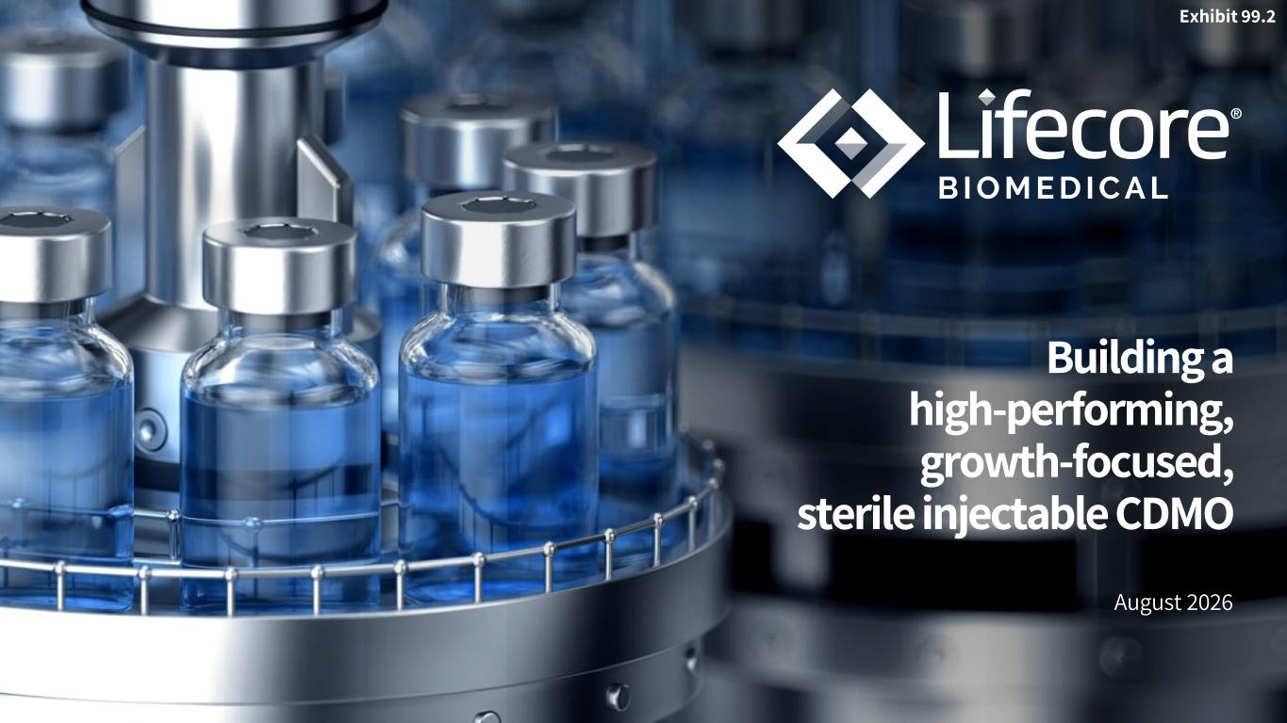

Building a high-performing, growth-focused, sterile injectable CDMO August 2026 Exhibit 99.2

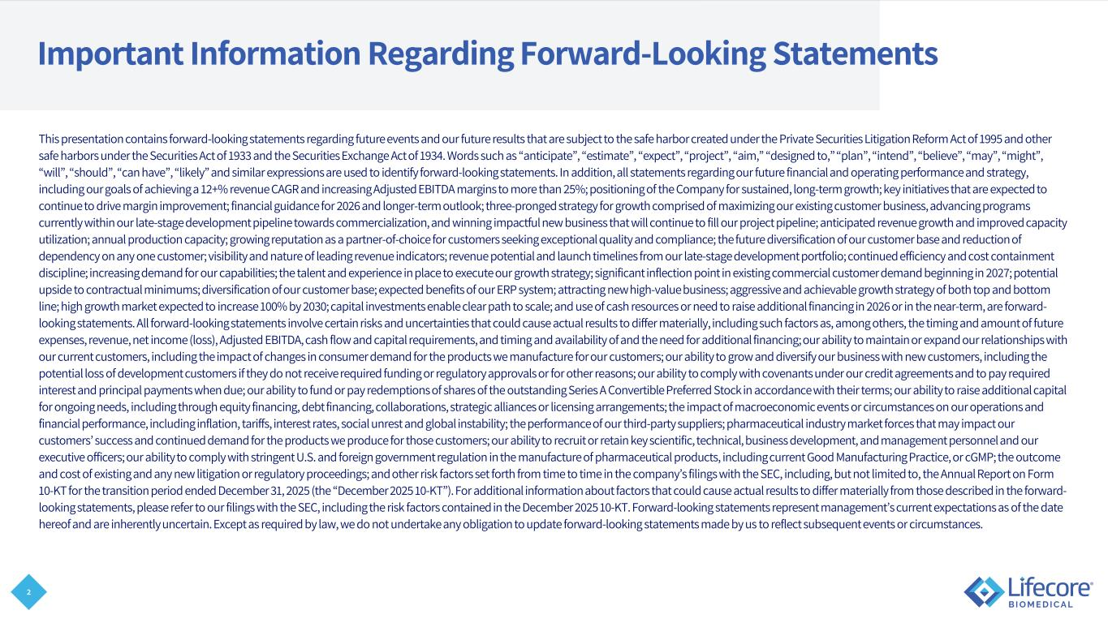
2 Important Information Regarding Forward-Looking Statements This presentation contains forward-looking statements regarding future events and our future results that are subject to the safe harbor created under the Private Securities Litigation Reform Act of 1995 and other safe harbors under the Securities Act of 1933 and the Securities Exchange Act of 1934. Words such as “anticipate”, “estimate”, “expect”, “project”, “aim,” “designed to,” “plan”, “intend”, “believe”, “may”, “might”, “will”, “should”, “can have”, “likely” and similar expressions are used to identify forward-looking statements. In addition, all statements regarding our future financial and operating performance and strategy, including our goals of achieving a 12+% revenue CAGR and increasing Adjusted EBITDA margins to more than 25%; positioning of the Company for sustained, long-term growth; key initiatives that are expected to continue to drive margin improvement; financial guidance for 2026 and longer-term outlook; three-pronged strategy for growth comprised of maximizing our existing customer business, advancing programs currently within our late-stage development pipeline towards commercialization, and winning impactful new business that will continue to fill our project pipeline; anticipated revenue growth and improved capacity utilization; annual production capacity; growing reputation as a partner-of-choice for customers seeking exceptional quality and compliance; the future diversification of our customer base and reduction of dependency on any one customer; visibility and nature of leading revenue indicators; revenue potential and launch timelines from our late-stage development portfolio; continued efficiency and cost containment discipline; increasing demand for our capabilities; the talent and experience in place to execute our growth strategy; significant inflection point in existing commercial customer demand beginning in 2027; potential upside to contractual minimums; diversification of our customer base; expected benefits of our ERP system; attracting new high-value business; aggressive and achievable growth strategy of both top and bottom line; high growth market expected to increase 100% by 2030; capital investments enable clear path to scale; and use of cash resources or need to raise additional financing in 2026 or in the near-term, are forward- looking statements. All forward-looking statements involve certain risks and uncertainties that could cause actual results to differ materially, including such factors as, among others, the timing and amount of future expenses, revenue, net income (loss), Adjusted EBITDA, cash flow and capital requirements, and timing and availability of and the need for additional financing; our ability to maintain or expand our relationships with our current customers, including the impact of changes in consumer demand for the products we manufacture for our customers; our ability to grow and diversify our business with new customers, including the potential loss of development customers if they do not receive required funding or regulatory approvals or for other reasons; our ability to comply with covenants under our credit agreements and to pay required interest and principal payments when due; our ability to fund or pay redemptions of shares of the outstanding Series A Convertible Preferred Stock in accordance with their terms; our ability to raise additional capital for ongoing needs, including through equity financing, debt financing, collaborations, strategic alliances or licensing arrangements; the impact of macroeconomic events or circumstances on our operations and financial performance, including inflation, tariffs, interest rates, social unrest and global instability; the performance of our third-party suppliers; pharmaceutical industry market forces that may impact our customers’ success and continued demand for the products we produce for those customers; our ability to recruit or retain key scientific, technical, business development, and management personnel and our executive officers; our ability to comply with stringent U.S. and foreign government regulation in the manufacture of pharmaceutical products, including current Good Manufacturing Practice, or cGMP; the outcome and cost of existing and any new litigation or regulatory proceedings; and other risk factors set forth from time to time in the company’s filings with the SEC, including, but not limited to, the Annual Report on Form 10-KT for the transition period ended December 31, 2025 (the “December 2025 10-KT”). For additional information about factors that could cause actual results to differ materially from those described in the forward- looking statements, please refer to our filings with the SEC, including the risk factors contained in the December 2025 10-KT. Forward-looking statements represent management’s current expectations as of the date hereof and are inherently uncertain. Except as required by law, we do not undertake any obligation to update forward-looking statements made by us to reflect subsequent events or circumstances.

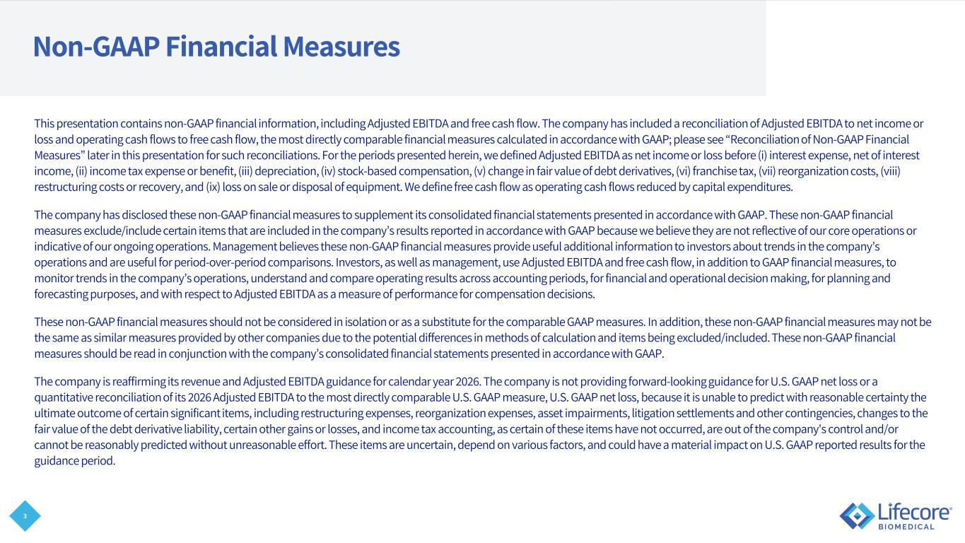
3 Non-GAAP Financial Measures This presentation contains non-GAAP financial information, including Adjusted EBITDA and free cash flow. The company has included a reconciliation of Adjusted EBITDA to net income or loss and operating cash flows to free cash flow, the most directly comparable financial measures calculated in accordance with GAAP; please see “Reconciliation of Non-GAAP Financial Measures” later in this presentation for such reconciliations. For the periods presented herein, we defined Adjusted EBITDA as net income or loss before (i) interest expense, net of interest income, (ii) income tax expense or benefit, (iii) depreciation, (iv) stock-based compensation, (v) change in fair value of debt derivatives, (vi) franchise tax, (vii) reorganization costs, (viii) restructuring costs or recovery, and (ix) loss on sale or disposal of equipment. We define free cash flow as operating cash flows reduced by capital expenditures. The company has disclosed these non-GAAP financial measures to supplement its consolidated financial statements presented in accordance with GAAP. These non-GAAP financial measures exclude/include certain items that are included in the company’s results reported in accordance with GAAP because we believe they are not reflective of our core operations or indicative of our ongoing operations. Management believes these non-GAAP financial measures provide useful additional information to investors about trends in the company’s operations and are useful for period-over-period comparisons. Investors, as well as management, use Adjusted EBITDA and free cash flow, in addition to GAAP financial measures, to monitor trends in the company’s operations, understand and compare operating results across accounting periods, for financial and operational decision making, for planning and forecasting purposes, and with respect to Adjusted EBITDA as a measure of performance for compensation decisions. These non-GAAP financial measures should not be considered in isolation or as a substitute for the comparable GAAP measures. In addition, these non-GAAP financial measures may not be the same as similar measures provided by other companies due to the potential differences in methods of calculation and items being excluded/included. These non-GAAP financial measures should be read in conjunction with the company’s consolidated financial statements presented in accordance with GAAP. The company is reaffirming its revenue and Adjusted EBITDA guidance for calendar year 2026. The company is not providing forward-looking guidance for U.S. GAAP net loss or a quantitative reconciliation of its 2026 Adjusted EBITDA to the most directly comparable U.S. GAAP measure, U.S. GAAP net loss, because it is unable to predict with reasonable certainty the ultimate outcome of certain significant items, including restructuring expenses, reorganization expenses, asset impairments, litigation settlements and other contingencies, changes to the fair value of the debt derivative liability, certain other gains or losses, and income tax accounting, as certain of these items have not occurred, are out of the company's control and/or cannot be reasonably predicted without unreasonable effort. These items are uncertain, depend on various factors, and could have a material impact on U.S. GAAP reported results for the guidance period.

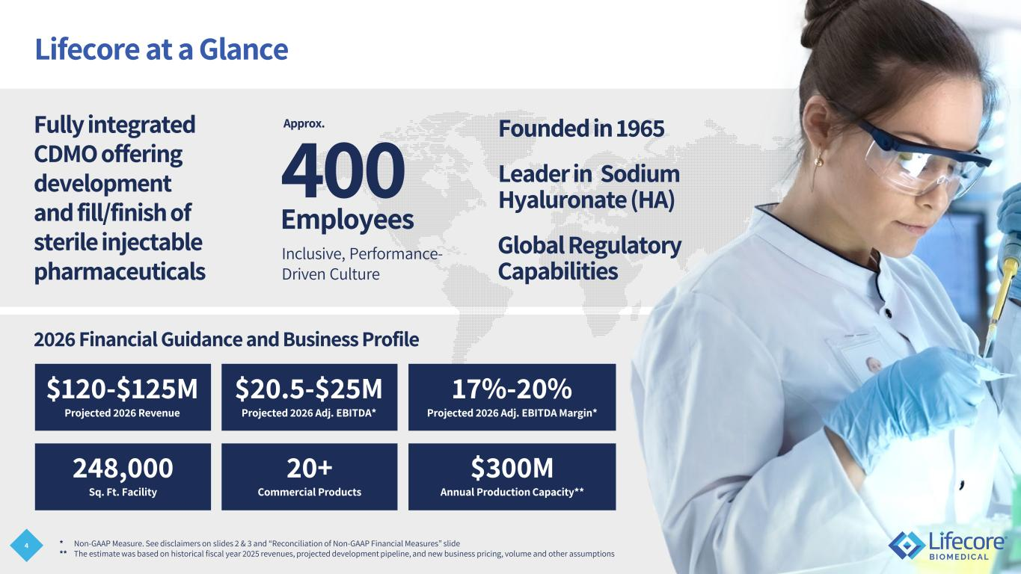
4 Lifecore at a Glance 400 Employees Inclusive, Performance- Driven Culture Fully integrated CDMO offering development and fill/finish of sterile injectable pharmaceuticals Leader in Sodium Hyaluronate (HA) Global Regulatory Capabilities Founded in 1965 * Non-GAAP Measure. See disclaimers on slides 2 & 3 and “Reconciliation of Non-GAAP Financial Measures” slide ** The estimate was based on historical fiscal year 2025 revenues, projected development pipeline, and new business pricing, volume and other assumptions Approx. 248,000 Sq. Ft. Facility $300M Annual Production Capacity** 20+ Commercial Products 2026 Financial Guidance and Business Profile $120-$125M Projected 2026 Revenue $20.5-$25M Projected 2026 Adj. EBITDA* 17%-20% Projected 2026 Adj. EBITDA Margin*

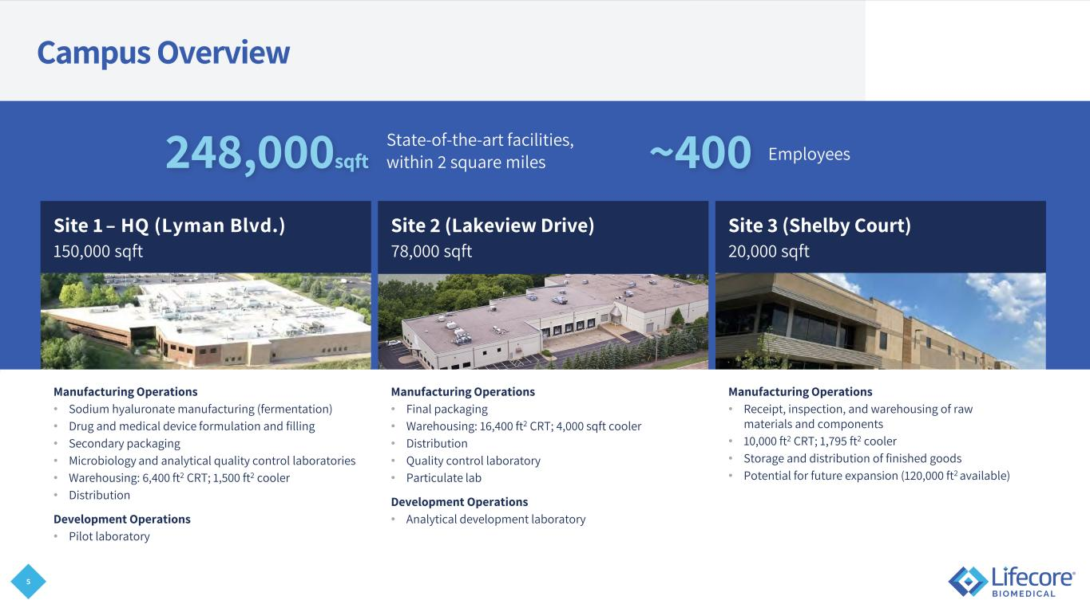
5 Campus Overview Site 1 – HQ (Lyman Blvd.) 150,000 sqft Site 2 (Lakeview Drive) 78,000 sqft Site 3 (Shelby Court) 20,000 sqft Manufacturing Operations • Sodium hyaluronate manufacturing (fermentation) • Drug and medical device formulation and filling • Secondary packaging • Microbiology and analytical quality control laboratories • Warehousing: 6,400 ft2 CRT; 1,500 ft2 cooler • Distribution Development Operations • Pilot laboratory Manufacturing Operations • Final packaging • Warehousing: 16,400 ft2 CRT; 4,000 sqft cooler • Distribution • Quality control laboratory • Particulate lab Development Operations • Analytical development laboratory Manufacturing Operations • Receipt, inspection, and warehousing of raw materials and components • 10,000 ft2 CRT; 1,795 ft2 cooler • Storage and distribution of finished goods • Potential for future expansion (120,000 ft2 available) 248,000sqft ~400State-of-the-art facilities, within 2 square miles Employees

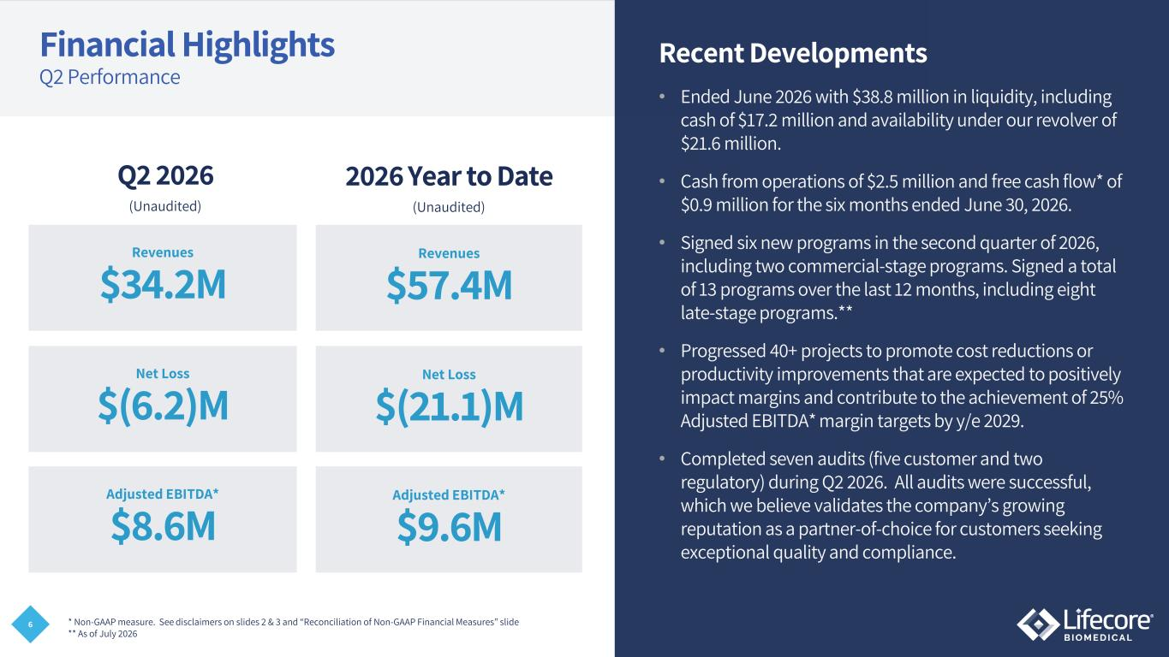
6 Financial Highlights Q2 Performance Recent Developments • Ended June 2026 with $38.8 million in liquidity, including cash of $17.2 million and availability under our revolver of $21.6 million. • Cash from operations of $2.5 million and free cash flow* of $0.9 million for the six months ended June 30, 2026. • Signed six new programs in the second quarter of 2026, including two commercial-stage programs. Signed a total of 13 programs over the last 12 months, including eight late-stage programs.** • Progressed 40+ projects to promote cost reductions or productivity improvements that are expected to positively impact margins and contribute to the achievement of 25% Adjusted EBITDA* margin targets by y/e 2029. • Completed seven audits (five customer and two regulatory) during Q2 2026. All audits were successful, which we believe validates the company’s growing reputation as a partner-of-choice for customers seeking exceptional quality and compliance. * Non-GAAP measure. See disclaimers on slides 2 & 3 and “Reconciliation of Non-GAAP Financial Measures” slide ** As of July 2026 Q2 2026 $34.2M Revenues $(6.2)M Net Loss $8.6M Adjusted EBITDA* (Unaudited) 2026 Year to Date $57.4M Revenues $(21.1)M Net Loss $9.6M Adjusted EBITDA* (Unaudited)

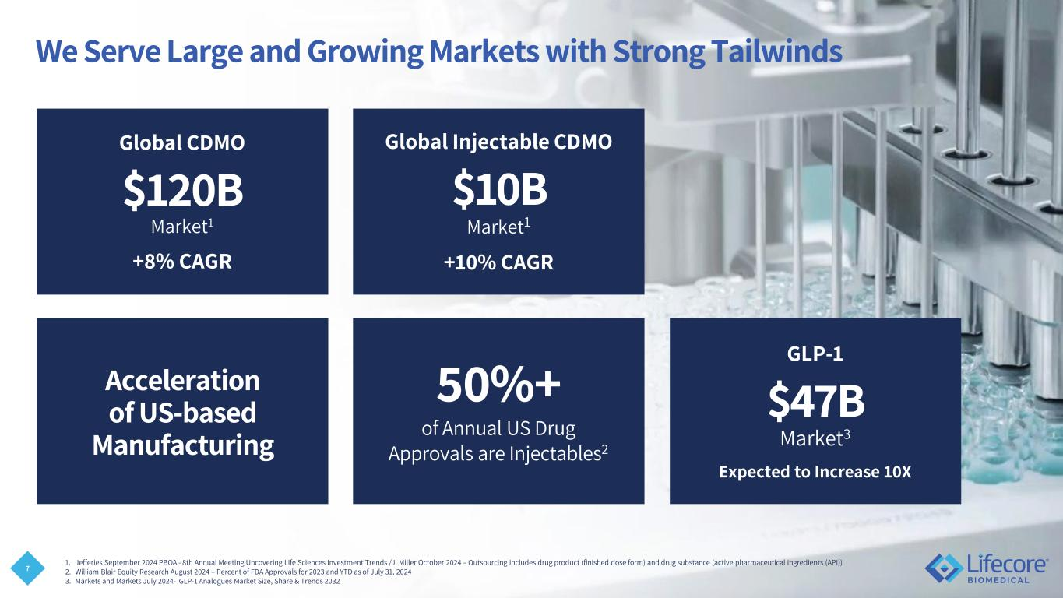
7 We Serve Large and Growing Markets with Strong Tailwinds Global Injectable CDMO $10B Market1 +10% CAGR Acceleration of US-based Manufacturing Global CDMO $120B Market1 +8% CAGR 50%+ of Annual US Drug Approvals are Injectables2 GLP-1 $47B Market3 Expected to Increase 10X 1. Jefferies September 2024 PBOA - 8th Annual Meeting Uncovering Life Sciences Investment Trends /J. Miller October 2024 – Outsourcing includes drug product (finished dose form) and drug substance (active pharmaceutical ingredients (API)) 2. William Blair Equity Research August 2024 – Percent of FDA Approvals for 2023 and YTD as of July 31, 2024 3. Markets and Markets July 2024- GLP-1 Analogues Market Size, Share & Trends 2032

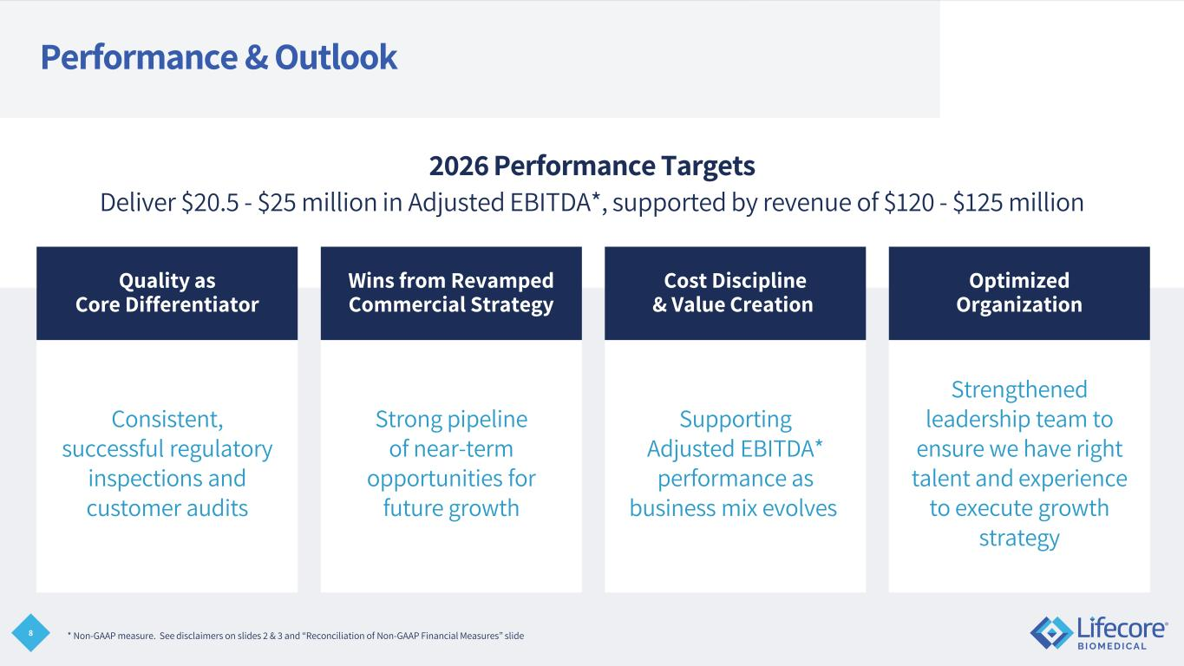
8 Consistent, successful regulatory inspections and customer audits Strong pipeline of near-term opportunities for future growth Supporting Adjusted EBITDA* performance as business mix evolves Strengthened leadership team to ensure we have right talent and experience to execute growth strategy Performance & Outlook Quality as Core Differentiator Wins from Revamped Commercial Strategy Cost Discipline & Value Creation Optimized Organization 2026 Performance Targets Deliver $20.5 - $25 million in Adjusted EBITDA*, supported by revenue of $120 - $125 million * Non-GAAP measure. See disclaimers on slides 2 & 3 and “Reconciliation of Non-GAAP Financial Measures” slide

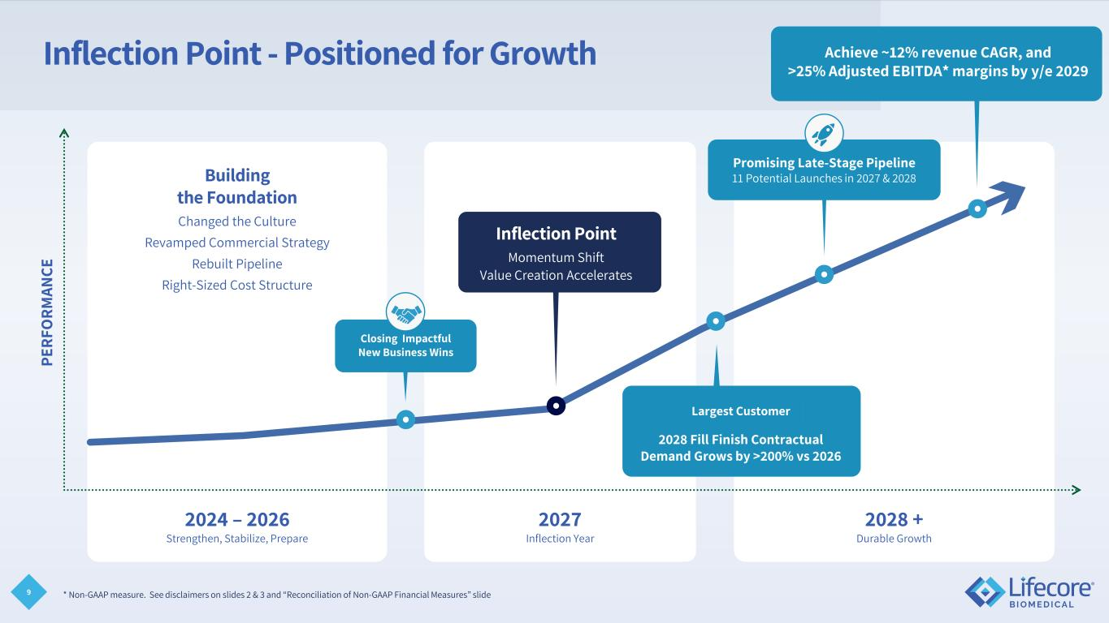
9 Inflection Point - Positioned for Growth 2027 Inflection Year 2024 – 2026 Strengthen, Stabilize, Prepare 2028 + Durable Growth Building the Foundation Changed the Culture Revamped Commercial Strategy Rebuilt Pipeline Right-Sized Cost Structure PE RF O RM AN CE 2028 Fill Finish Contractual Demand Grows by >200% vs 2026 Closing Impactful New Business Wins Inflection Point Momentum Shift Value Creation Accelerates Promising Late-Stage Pipeline 11 Potential Launches in 2027 & 2028 Sustain 10-5-3 Close – File - Launch Largest Customer Achieve ~12% revenue CAGR, and >25% Adjusted EBITDA* margins by y/e 2029 * Non-GAAP measure. See disclaimers on slides 2 & 3 and “Reconciliation of Non-GAAP Financial Measures” slide

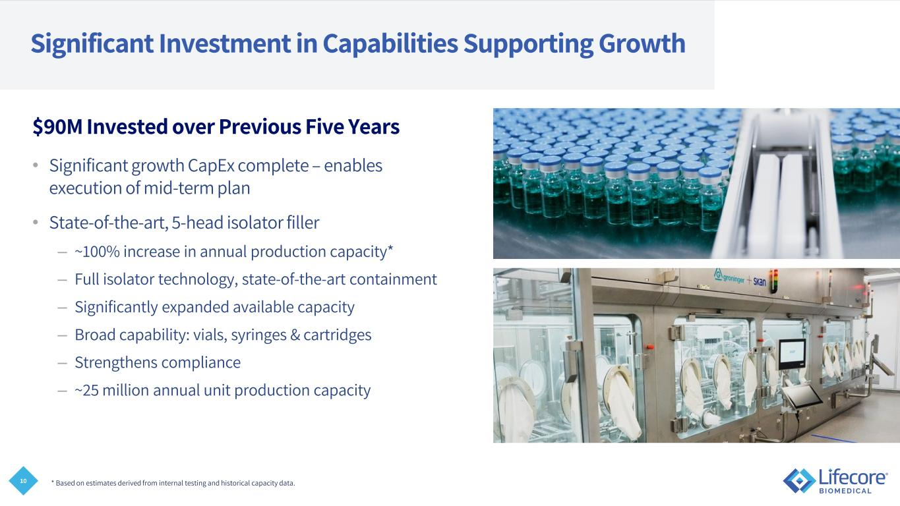
10 $90M Invested over Previous Five Years • Significant growth CapEx complete – enables execution of mid-term plan • State-of-the-art, 5-head isolator filler – ~100% increase in annual production capacity* – Full isolator technology, state-of-the-art containment – Significantly expanded available capacity – Broad capability: vials, syringes & cartridges – Strengthens compliance – ~25 million annual unit production capacity * Based on estimates derived from internal testing and historical capacity data. Significant Investment in Capabilities Supporting Growth

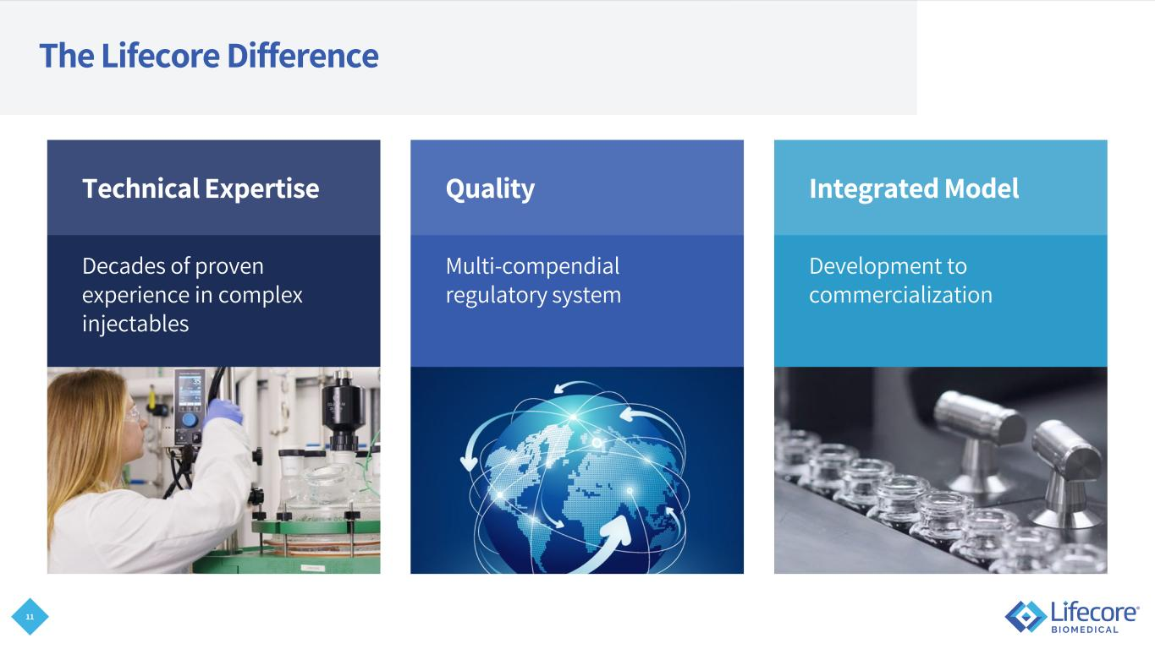
11 The Lifecore Difference Technical Expertise Decades of proven experience in complex injectables Integrated Model Development to commercialization Quality Multi-compendial regulatory system

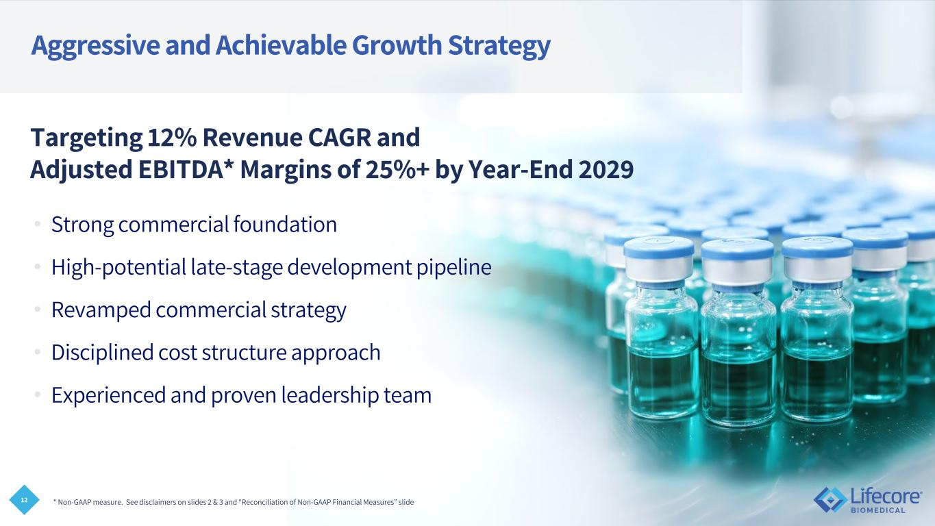
12 Aggressive and Achievable Growth Strategy • Strong commercial foundation • High-potential late-stage development pipeline • Revamped commercial strategy • Disciplined cost structure approach • Experienced and proven leadership team Targeting 12% Revenue CAGR and Adjusted EBITDA* Margins of 25%+ by Year-End 2029 * Non-GAAP measure. See disclaimers on slides 2 & 3 and “Reconciliation of Non-GAAP Financial Measures” slide

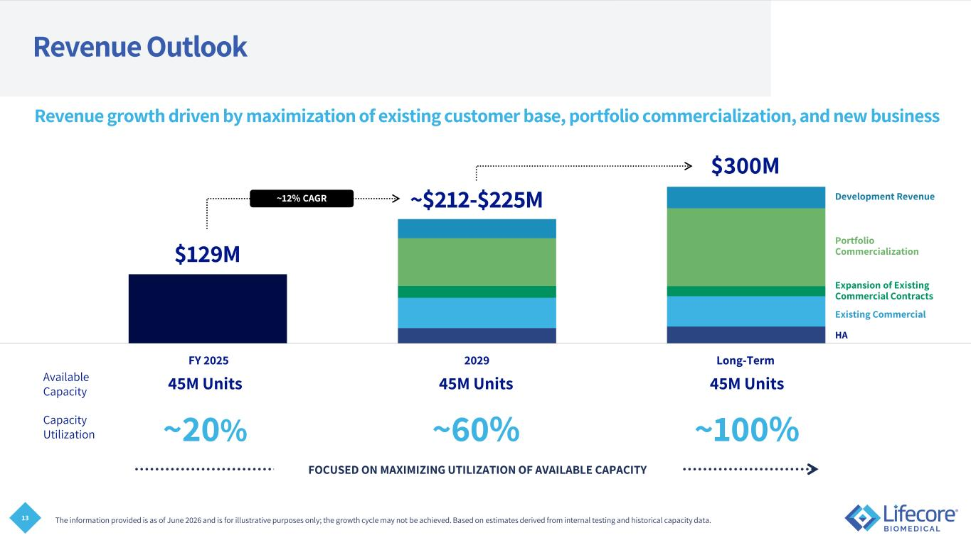
13 FOCUSED ON MAXIMIZING UTILIZATION OF AVAILABLE CAPACITY Revenue Outlook Revenue growth driven by maximization of existing customer base, portfolio commercialization, and new business 45M Units 45M Units 45M Units ~20% ~60% ~100% Available Capacity Capacity Utilization The information provided is as of June 2026 and is for illustrative purposes only; the growth cycle may not be achieved. Based on estimates derived from internal testing and historical capacity data. FY 2025 2029 Long-Term ~12% CAGR $129M ~$212-$225M $300M HA Existing Commercial Expansion of Existing Commercial Contracts Portfolio Commercialization Development Revenue

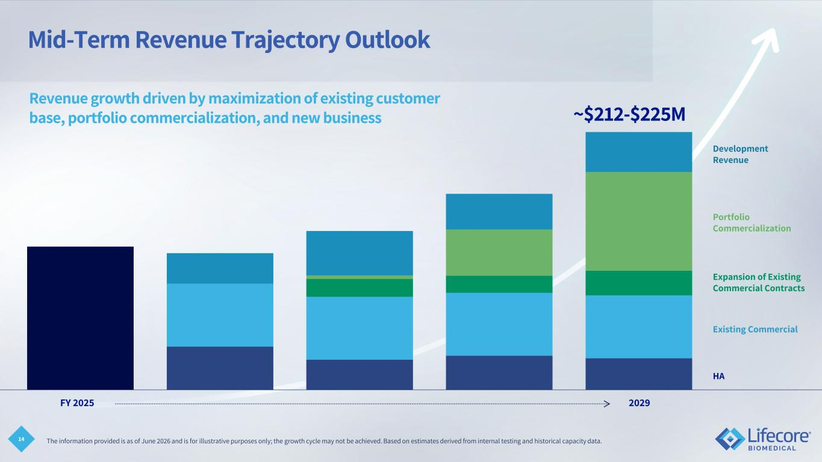
14 Mid-Term Revenue Trajectory Outlook Revenue growth driven by maximization of existing customer base, portfolio commercialization, and new business FY 2025 2029 ~$212-$225M HA Existing Commercial Expansion of Existing Commercial Contracts Portfolio Commercialization Development Revenue The information provided is as of June 2026 and is for illustrative purposes only; the growth cycle may not be achieved. Based on estimates derived from internal testing and historical capacity data.

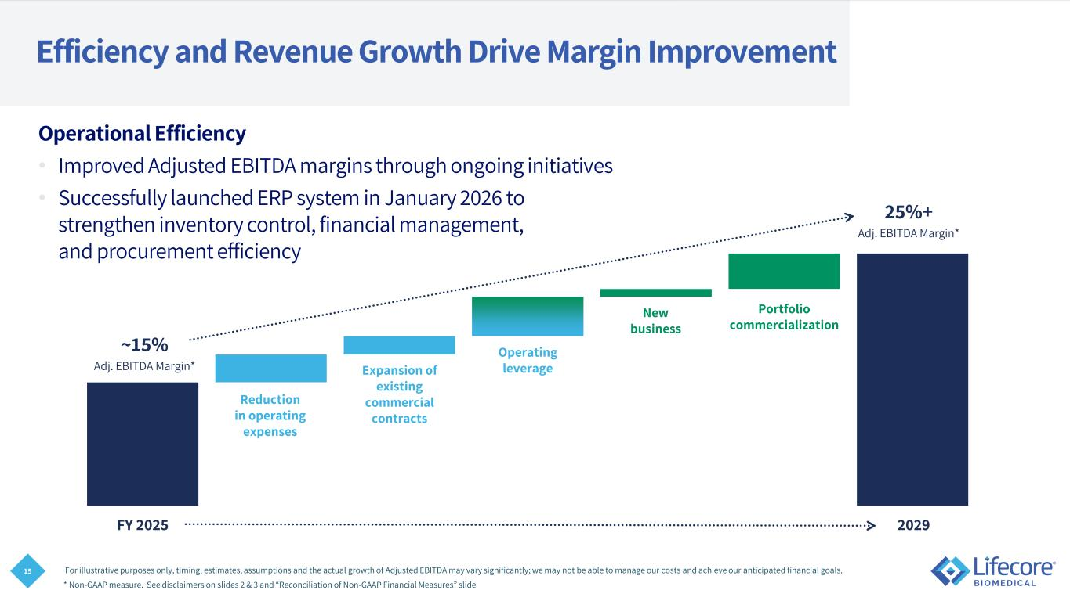
15 FY 2025 2029 Efficiency and Revenue Growth Drive Margin Improvement Operational Efficiency • Improved Adjusted EBITDA margins through ongoing initiatives • Successfully launched ERP system in January 2026 to strengthen inventory control, financial management, and procurement efficiency For illustrative purposes only, timing, estimates, assumptions and the actual growth of Adjusted EBITDA may vary significantly; we may not be able to manage our costs and achieve our anticipated financial goals. ~15% 25%+ Adj. EBITDA Margin* Adj. EBITDA Margin* Reduction in operating expenses Expansion of existing commercial contracts Portfolio commercialization New business Operating leverage * Non-GAAP measure. See disclaimers on slides 2 & 3 and “Reconciliation of Non-GAAP Financial Measures” slide

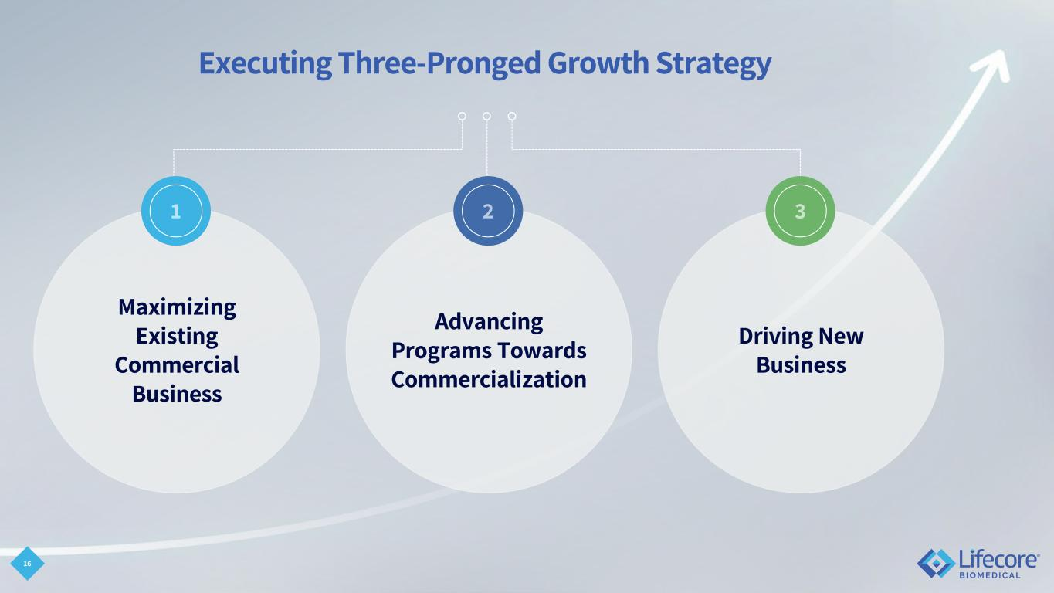
Executing Three-Pronged Growth Strategy 16 Maximizing Existing Commercial Business Advancing Programs Towards Commercialization Driving New Business

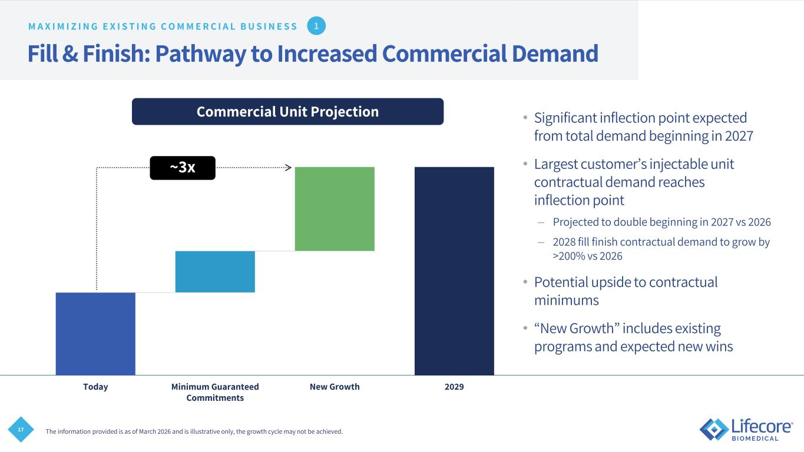
17 Fill & Finish: Pathway to Increased Commercial Demand • Significant inflection point expected from total demand beginning in 2027 • Largest customer’s injectable unit contractual demand reaches inflection point – Projected to double beginning in 2027 vs 2026 – 2028 fill finish contractual demand to grow by >200% vs 2026 • Potential upside to contractual minimums • “New Growth” includes existing programs and expected new wins The information provided is as of March 2026 and is illustrative only, the growth cycle may not be achieved. M A X I M I Z I N G E X I S T I N G C O M M E R C I A L B U S I N E S S Today Minimum Guaranteed Commitments New Growth 2029 Commercial Unit Projection ~3x

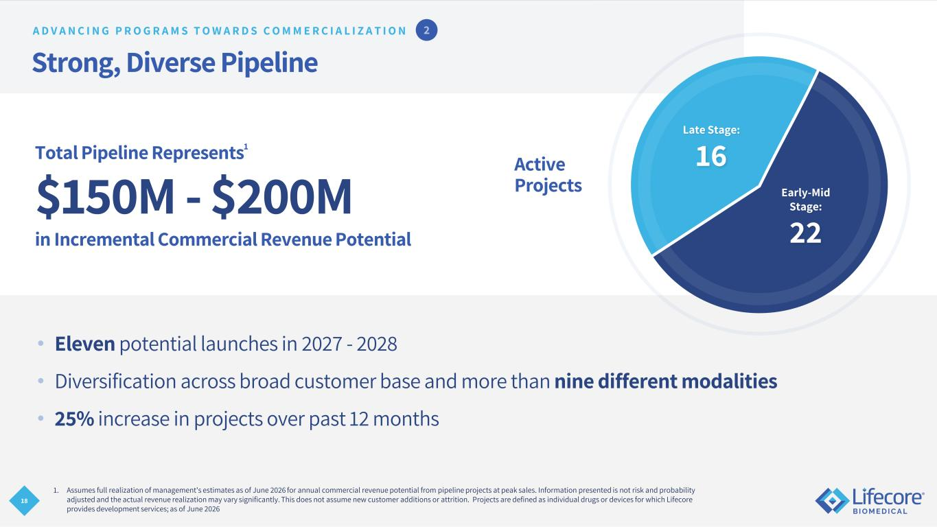
18 Strong, Diverse Pipeline • Eleven potential launches in 2027 - 2028 • Diversification across broad customer base and more than nine different modalities • 25% increase in projects over past 12 months Total Pipeline Represents1 $150M - $200M in Incremental Commercial Revenue Potential 1. Assumes full realization of management's estimates as of June 2026 for annual commercial revenue potential from pipeline projects at peak sales. Information presented is not risk and probability adjusted and the actual revenue realization may vary significantly. This does not assume new customer additions or attrition. Projects are defined as individual drugs or devices for which Lifecore provides development services; as of June 2026 Active Projects Late Stage: 16 Early-Mid Stage: 22 A D V A N C I N G P R O G R A M S T O W A R D S C O M M E R C I A L I Z A T I O N

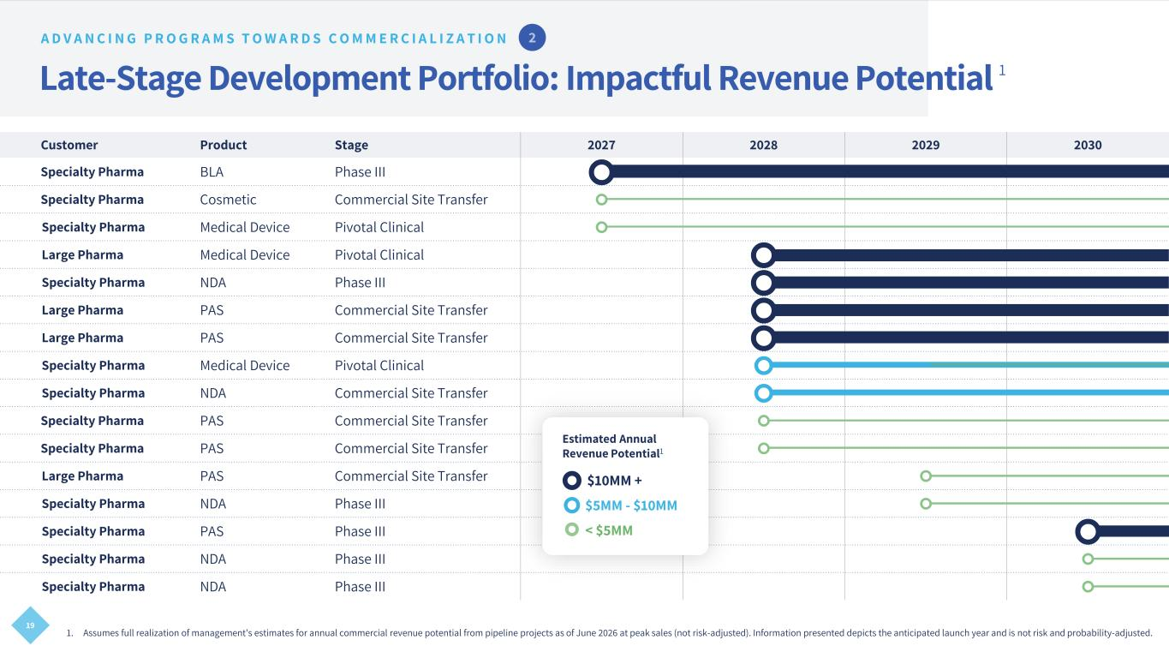
19 Customer Product Stage 2027 2028 2029 2030 Specialty Pharma BLA Phase III  Specialty Pharma Cosmetic Commercial Site Transfer  Specialty Pharma Medical Device Pivotal Clinical  Large Pharma Medical Device Pivotal Clinical  Specialty Pharma NDA Phase III  Large Pharma PAS Commercial Site Transfer  Large Pharma PAS Commercial Site Transfer  Specialty Pharma Medical Device Pivotal Clinical  Specialty Pharma NDA Commercial Site Transfer  Specialty Pharma PAS Commercial Site Transfer  Specialty Pharma PAS Commercial Site Transfer  Large Pharma PAS Commercial Site Transfer  Specialty Pharma NDA Phase III  Specialty Pharma PAS Phase III  Specialty Pharma NDA Phase III  Specialty Pharma NDA Phase III  Late-Stage Development Portfolio: Impactful Revenue Potential 1 $10MM + $5MM - $10MM < $5MM Estimated Annual Revenue Potential1 A D V A N C I N G P R O G R A M S T O W A R D S C O M M E R C I A L I Z A T I O N 1. Assumes full realization of management's estimates for annual commercial revenue potential from pipeline projects as of June 2026 at peak sales (not risk-adjusted). Information presented depicts the anticipated launch year and is not risk and probability-adjusted.

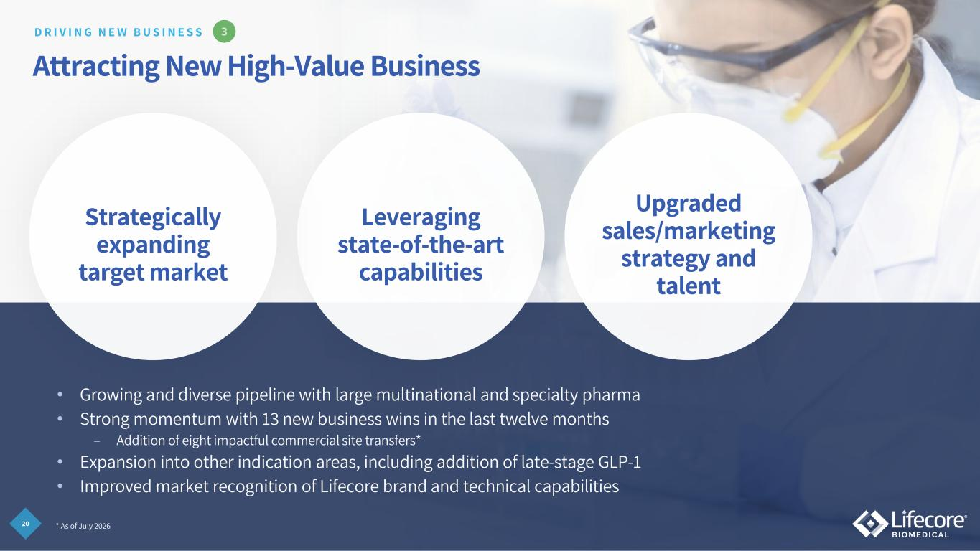
20 Attracting New High-Value Business Leveraging state-of-the-art capabilities Strategically expanding target market Upgraded sales/marketing strategy and talent D R I V I N G N E W B U S I N E S S • Growing and diverse pipeline with large multinational and specialty pharma • Strong momentum with 13 new business wins in the last twelve months – Addition of eight impactful commercial site transfers* • Expansion into other indication areas, including addition of late-stage GLP-1 • Improved market recognition of Lifecore brand and technical capabilities * As of July 2026

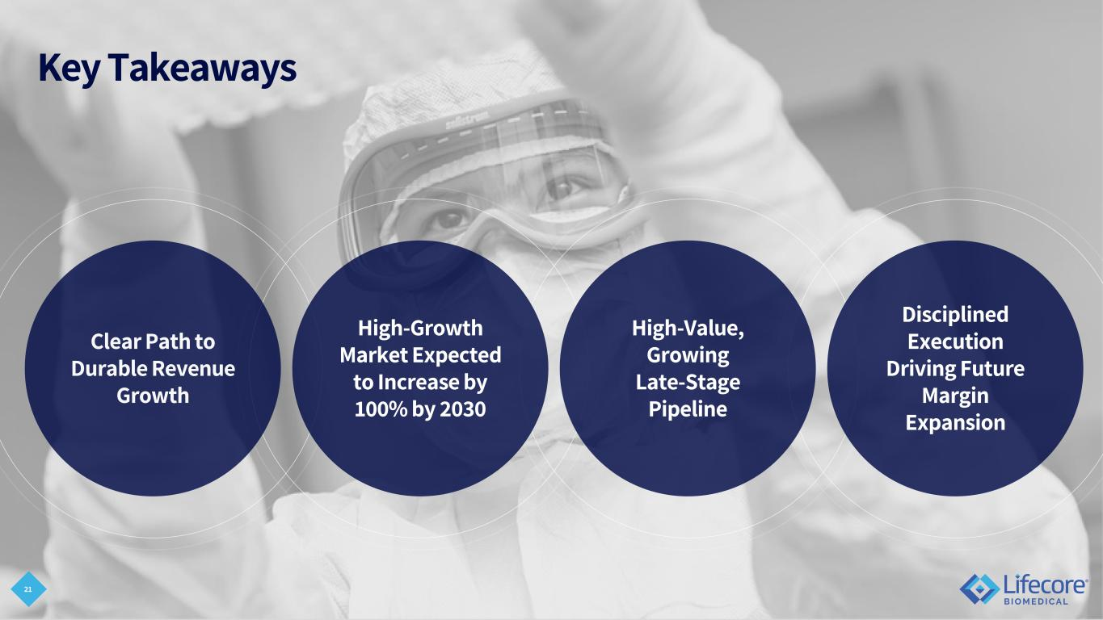
21 Key Takeaways High-Growth Market Expected to Increase by 100% by 2030 High-Value, Growing Late-Stage Pipeline Disciplined Execution Driving Future Margin Expansion Clear Path to Durable Revenue Growth

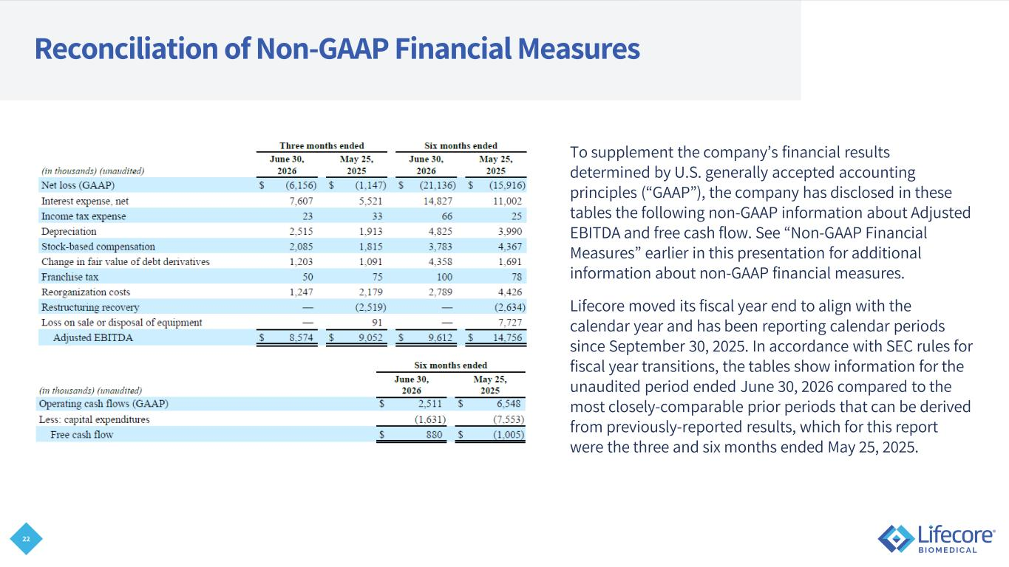
22 Reconciliation of Non-GAAP Financial Measures To supplement the company’s financial results determined by U.S. generally accepted accounting principles (“GAAP”), the company has disclosed in these tables the following non-GAAP information about Adjusted EBITDA and free cash flow. See “Non-GAAP Financial Measures” earlier in this presentation for additional information about non-GAAP financial measures. Lifecore moved its fiscal year end to align with the calendar year and has been reporting calendar periods since September 30, 2025. In accordance with SEC rules for fiscal year transitions, the tables show information for the unaudited period ended June 30, 2026 compared to the most closely-comparable prior periods that can be derived from previously-reported results, which for this report were the three and six months ended May 25, 2025.

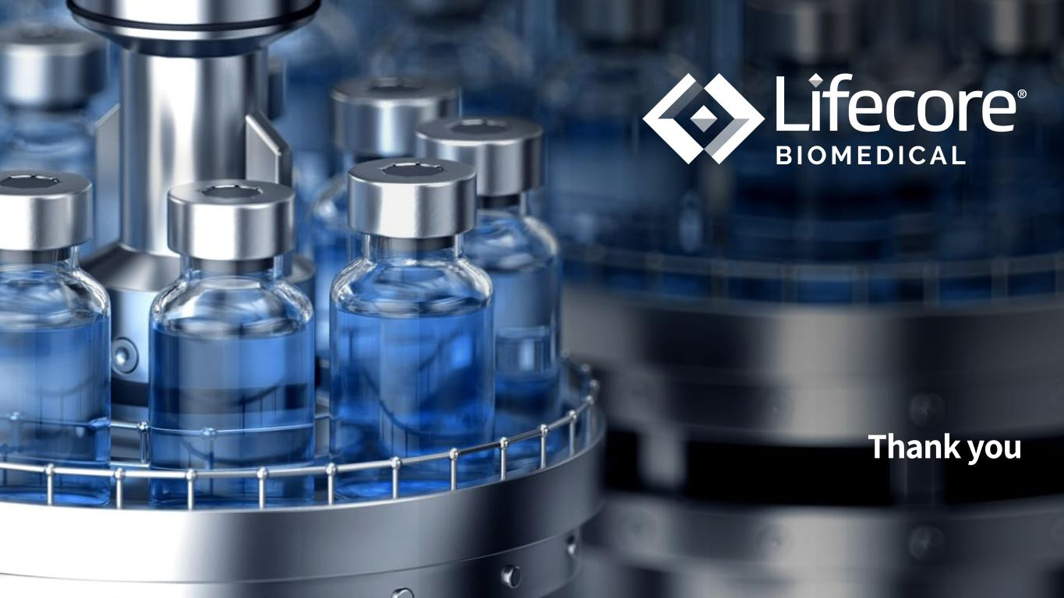
Thank you

